Finding a singular PAN angle from two cameras

The need for obtaining one single PAN angle from both cameras is due to two facts:

1) Historically, the lab worked with a head that had a neck and needed a singular pan and tilt value (LVerge, RVerge, Pan, and Tilt). In the current configuration of the head, there are two independent pan and tilt values. Hence, there needed to be a conversion to obtain a single pan angle, “α”.

2) To compute the position of an object of interest marked by the angles of the cameras, a single pan and tilt angle are necessary to formulate distance equations for X, Y, and Z.

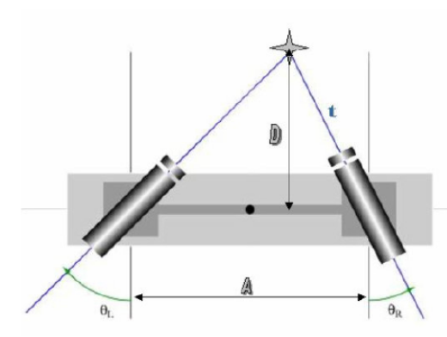 | 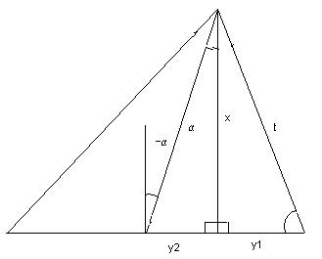

From our previous mathematical model, we found t to be:

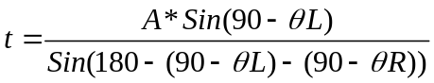

Simplifying,

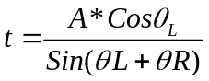

Also, we found D to be:

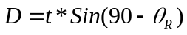

Substituting for t,

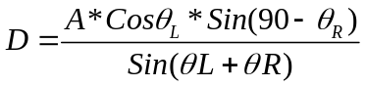

From the above diagram we see that:

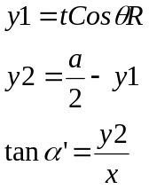

We can sub for the above equation and get:

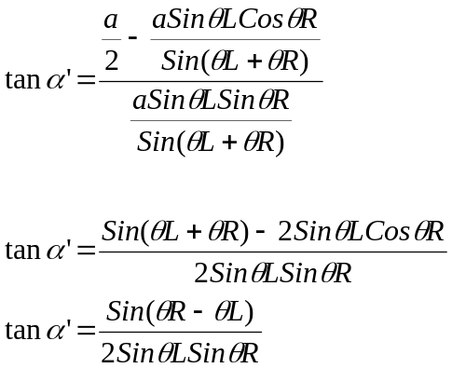

So, we just find the arctan of alpha to get our desired angle (look at fig. 1):

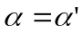

This is the actual mathematical model that was used in the PTCatch.cpp source code.

This angle as well as an average of both tilts can be obtained from the vector signal for the PTCatch component by invoking operation 2. The angles outputted would be:
left pan, left tilt, right pan, right tilt, overall pan angle, average tilt angle.
There are other models that can be adopted to find this angle. One of them was presented by Prof. Peters. It will be presented here below to show that the final result is identical.

The model is based on the following diagram:

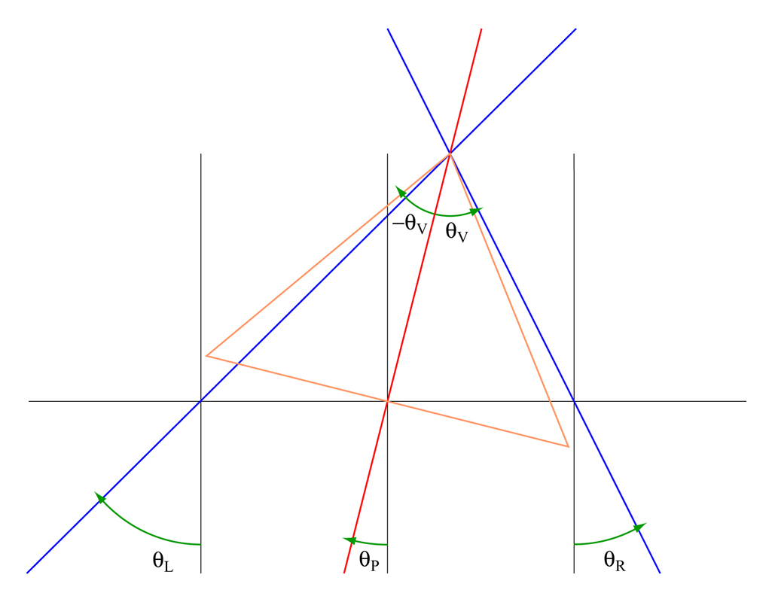
Where clockwise rotations represent negative angles and counterclockwise rotations represent positive angles.
Based on this model, you can get θR and θL:

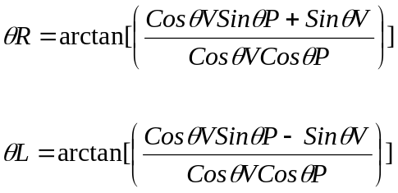

And the Pan angle is:

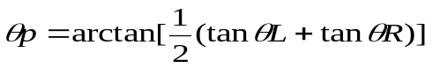

We can solve for the following identity:

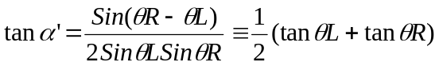

Solving for the LHS:

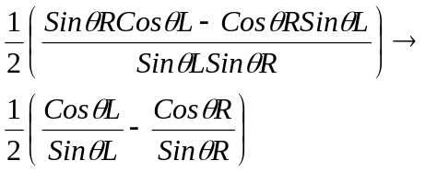

Here we have to realize that the angles that were selected for both models are different. So:

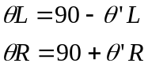

Hence, by doing the appropriate substitution we get:

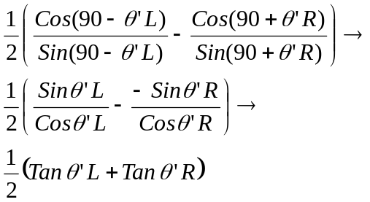

Hence both sides of the equation are equal.

